RC tutorial 004 - Alignment with vertical profile

===========================================

· Assumed RailCOMPLETE skills: Previous lessons.

· Assumed railway skills: You know about railway geometry and how vertical profile is represented as Z(s) along that geometry.

· Time to spend: 1 hour

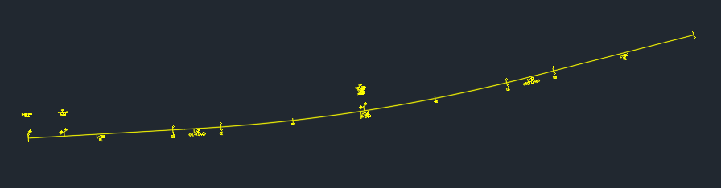

1. This tutorial makes use of the Norwegian State Railways' model (Bane NOR DNA).

2. Start the Alignment Manager and select the alignment "T01". Keep it selected at all times. You may keep the "Bind to Selection" box checked in the lower left corner of the Alignment Manager window, to synchronize modelspace alignment selections with the current AM datagrid.

3. Activate the Alignment\Vertical tab. You will see a datagrid displaying the actual vertical profile details of your alignment.

4. Check "Extended View" to see more details, such as Length 3D (taking the effect of a varying elevation into account).

5. If you want to check out your alignment in 3D then select it, right-click and select "RailCOMPLETE Export 3D" (export to 3D using previous (or default) settings).

6. Activate the RC-ShowProfile tool, and check "Enable Edit" in Alignment Manager to allow for modifications.

7. Now, play around in the Alignment Manager vertical profile datagrid and make changes directly in the datagrid.

8. Each time you have made changes to the vertical profile you may visualize them in 3D by selecting the alignment, right-clicking and selecting "RailCOMPLETE Export 3D".

9. You may well delete the existing vertical annotations (select in modelspace and press DELETE) since you are going to revise them anyway.

10. You will see your changes directly in modelspace while you make modifications to the alignment profile in Alignment Manager, as long as the RC-ShowProfile tool is activated.

11. When you're done making amendments to the vertical profile, copy your new annotations to the drawing: Select the alignment with RC-ShowProfile activated, then right-click and select 'RailCOMPLETE Annotation\Copy Annotations to Drawing'.  
NOTE: For some reason, AutoCAD hides such annotations from time to time. Using the AutoCAD command AUDIT+"Yes" will usually fix this problem, even if AutoCAD reports "Total errors found 0 fixed 0.".

12. Revert to the Alignment\Vertical tab, check 'Extended View' and mark the T01 alignment. The Elevation column that you see here is the function 'Z(s)' where Z denotes an elevation above sea level, and s denotes the Position, i.e. the distance traveled along the alignment's geometry (in the XY-plane. Note that the actual length (the 3D length) can be longer than the projected length onto the geometry in the XY plane (2D length), due to the lenghtening effect of ups and downs.

13. Vertical profile is expressed using Points of Vertical Intersection - PVI's. These are points belonging to the vertical trajectory Z(s) as long as Z(s) is a piecewise linear function. But as soon as you involve non-linear transition curves (circular arcs or other transitions) between straight segments of Z(s), then the PVI's are located where the extensions to these straight lines would have met. When the PVI is located above the transition curve we call it a 'Crest'. When the PVI is located below the transition curve we call it a 'Sag'.

14. In our data example, there is one PVI with a given radius. This means that the vertical curve Z(s) will consist of a circular arc segment with that radius. Where the transition from the preceding straight line starts (the Vertical Transition Start, VTS) and where it ends (the Vertical Transition End, VTE), will depend on the steepness - the gradients - of the preceding and the succeeding straight lines.

15. For Bane NOR, VTS is annotated as "SE1" and VTE is annotated as "SE2".

16. Crests are annotated as "HBP" and sags are annotated as "LBP" in the Bane NOR DNA.

17. The PVI's Z-coordinate is shown as "m.o.h." in the Bane NOR annotations, meaning "m.a.s.l." (meters above sea level).

18. Check "Enable Edit" in the \Alignment\Vertical tab to make modifications again to the vertical profile.

19. To add a new row with vertical data, place your cursor in the lower, empty row and start typing in any of the columns. When you enter or modify the mileage (a linear mesasure along the alignment) or the position (the distance traveled from start of alignment), then the row will move itself to the correct position, i.e., sorting rows automatically based on mileage.

20. To delete a row with vertical profile information, click in the leftmost box of that row (or multiple rows) to mark all cells in that row, then press the DELETE button.

21. Experiment with Copy/Paste of vertical profile data between different alignments. You can copy a numerical value from a single cell in the source alignment's vertical datagrid, or you may copy multiple cells in one operation. Just note that you must mark an identical cell area (and check 'Enable Edit') in the target alignment datagrid, otherwise your paste operation will fail.

22. Experiment with Copy/Paste between an alignment datagrid and an Excel spreadsheet. You might experience comma/period conversion troubles, this will be due to differences between 'culture' (language / character sets) between your CAD system and your operating system.

23. Note that PVI's will often start before or end after your geometry does. Say for instance that your geoemtry starts in the middle of a vertical profile circular curve - then you should have the crest / sag PVI located outside the geometry, so you will also see the preceding (or the following) PVI in order to pinpoint the preceding / succeeding profile straight line element's gradient.

24. Also note that your vertical profile might start and end somewhere inside the extent of the geometry, i.e. not all the geometry would have a well-defined Z-coordinate. In such cases, you would experience 'missing profile data' (missing Z-coordinate) troubles in many built-in Lua formulas and in 3D rendering situations. See also tutorials on Lua programming and on 3D export.

Please check our website www.railcomplete.com for updates.

Corrections and suggestions are welcome to support@railcomplete.no.

Thank you for using RC Tutorials!